June 14, 2022
Notice of Award

Please be advised that the following contract has been awarded:

Description of Goods: Confederation College Thunder Bay Campus Roof Replacement – SD-5 and SD-6 Portions only

Bids Received: Lakehead Roofing and Metal Cladding Ltd.
$560,500.00

Rugged Air Industries Ltd.
$575,338.00

Bur-Met Contracting Ltd.
$ $608,574.80

Awarded to: Lakehead Roofing and Metal Cladding Ltd.
1190 Russell St., Thunder Bay, ON P7B 5N2

Date of Award: June 14, 2022

Value of Tender: Approximately $560,500 (plus HST)

Circumstances: Public Tender #T-22-003

Sincerely,
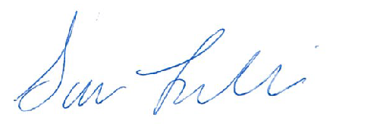

Sara Leclair, Purchasing Officer

