July 6, 2022
Notice of Award

Please be advised that the following contract has been awarded:

Description of Goods: HEO Contracted Trainer - Primary

Awarded to: LTL Contracting Ltd.
227 Highway 527
Shuniah, ON P7A 0N4

Date of Award: May 30, 2022

Value of Tender: $ 155,742.83 HST

Circumstances: Public RFP #P-22-004 April 20, 2022

Sincerely,
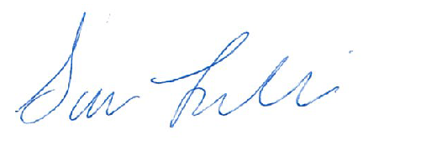

Sara Leclair, Purchasing Officer

