August 4, 2022
Notice of Award

Please be advised that the following contract has been awarded:

Description of Goods: HEO Contracted Trainer - Secondary

Awarded to: Fireside Transportation Ltd.
191 Cougar Cres.
Thunder Bay, ON P7C 0B7

Date of Award: June 14, 2022

Value of Tender: $ 144,800 + HST

Circumstances: Public RFP #P-22-004 April 20, 2022

Sincerely,
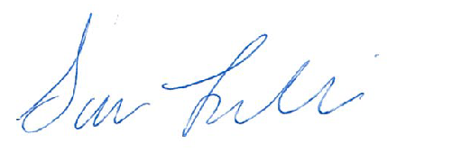

Sara Leclair, Purchasing Officer

