July 6, 2022
Notice of Award

Please be advised that the following contract has been awarded:

Description of Goods: RFP #P-21-020 Cessna 172S Flight Training Devices

Awarded to: Frasca International Inc.
906 Airport Road
Urbana, Illinois 61802-7375, U.S.A

Date of Award: July 6, 2022

Value of Tender: $ 563,398.00 USD + HST

Circumstances: Public RFP #P-21-020 dated February 10, 2022

Sincerely,
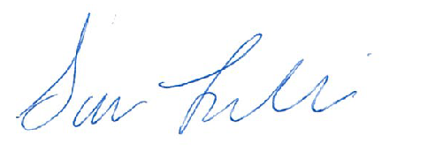

Sara Leclair, Purchasing Officer

