August 4, 2022
Notice of Award

Please be advised that the following contract has been awarded:

Description of Goods: Janitorial Services Thunder Bay and Kenora Campuses

Awarded to: BEST Service Pros. Ltd.
101-85 Schooner St.
Coquitlam, BC V3K 7A8

Date of Award: July 5, 2022

Value of Tender: $ 1,228,528.09/year + HST

Circumstances: Public RFP #P-22-006 dated April 27, 2022

Sincerely,
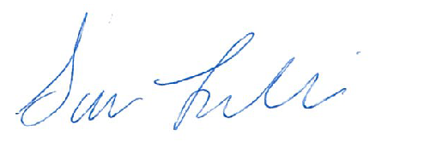

Sara Leclair, Purchasing Officer

