

**Posting Your Course Outline**

Follow the steps below to post your course outline for your students in Blackboard. You can also use these steps to post regular content items, such as assignment instructions and PowerPoint files.

1. Log in to Blackboard and open the course you’d like to post your course outline within. Make sure you have the digital PDF copy of your course outline before proceeding. Visit <http://www.confederationcollege.ca/academics> for more information on obtaining this file.
2. 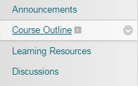Each course is built with a content area dedicated to posting the course outline. This is so students can find their course outlines easily in all of their courses. We recommend putting your course outline in this Course Outline area. **Click** the **Course Outline** menu item.
3. 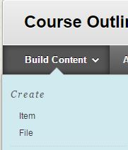Within this area, you will see some content creation items along the top of the page. Mouse over the **Build Content** menu option, and then click on the **Item** option.
4. 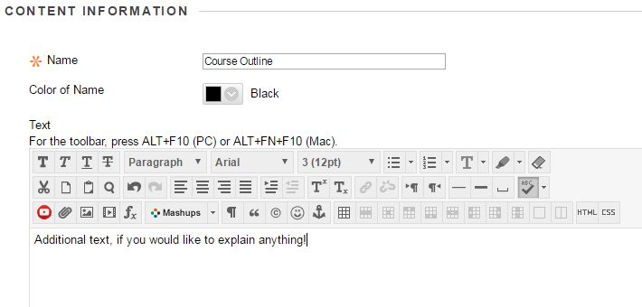This will bring you to the item creation interface. Enter **Course Outline** for the **Name.** No additional text is necessary, but you may add an additional explanation that this item is the course outline in the text area if you wish.
5. 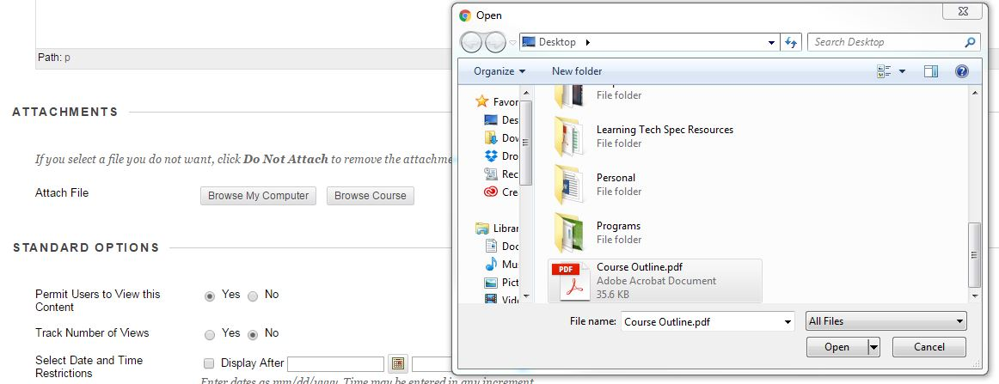Next, you will need to **attach** your PDF file to this content item. You can do this by using the **Attachments -> Attach File -> Browse My Computer** option. This allows you to select the PDF you’d like to upload into the course. Once attached, you will see the file listed under the Attachments section.
6. Ensure that the **Permit Users to View this Content** is set to **Yes.**
7. **Submit!**  Once submitted, you will be brought back to the course outline content area where you will see your new course outline item.