

**Posting an Announcement**

Follow the steps below to post an announcement to your students in Blackboard.

1. Log in to Blackboard and open the course you’d like to make an announcement within.
2. 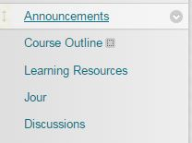Access the **Announcements** link in your course menu. This will open the Announcements tool.
3. 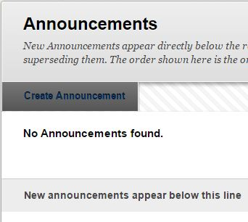Within the **Announcements** page, click on **Create Announcement** button.
4. Within this page, you will need to add a subject line and a message for your announcement. Use the rich text editor tools to create an announcement. You can also add images and other embedded content such as YouTube videos!  
   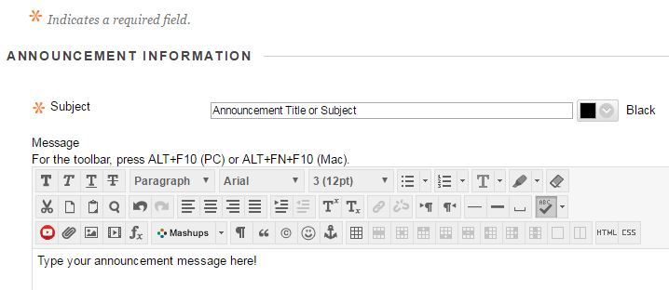
5. 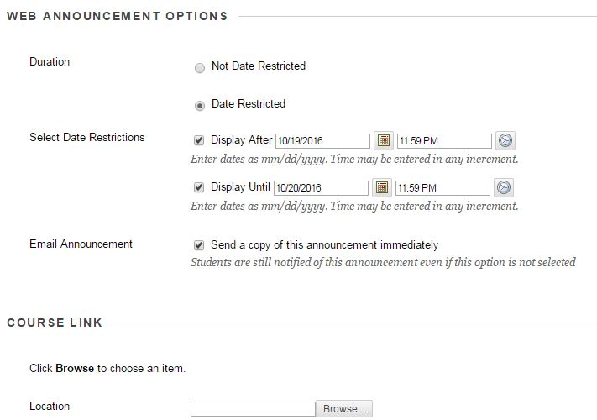Some final options include date restrictions, which allow you to control the time and date an announcement will be released and hidden. Additionally, you can opt to send the announcement to students via email, and include a course link to an important or relevant location in the course.
6. Click **Submit!** Your announcement will now appear on the Announcements page.