

**Making Your Course Available**

Follow the steps below to make your course available in Blackboard.

1. Log into Blackboard and select your course from the **My Courses** tab.
   1. 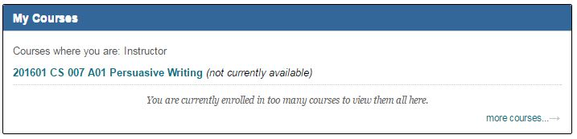If your course is not yet available, you will see the message ***(not currently available)***next to the course title.
2. Within your course, access the **Course Management** toolbar on the left of the screen. Within the **Control Panel,** click the **Customization** option.
3. 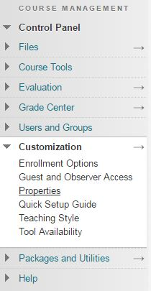Now, click on **Properties.**
4. 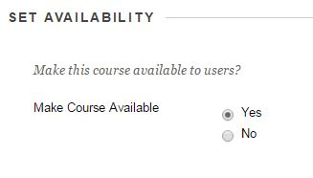Within this page, there is an option for making the course available. Ensure this is set to **Yes.**
5. Now click **Submit.** Your students will now be able to access this course within Blackboard. Ensure that all of your courses are available by 9 am on the date of the first class!