

**Creating a Blackboard Collaborate Session**

Follow the steps below to create and link students to a Blackboard Collaborate session.

1. Login and access your Blackboard course.
2. 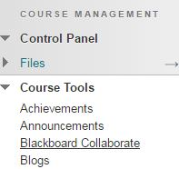Under your **Course Management** toolbar, click on the **Course Tools** area, and then click the **Blackboard Collaborate** option.
3. Within this page, you can join your **Course Room** or you can **Schedule a Session.** Depending on your needs, you can allow students to join your always-open Course Room, or schedule a specific time and date for your class to meet. This tutorial will focus on scheduling a session.
4. 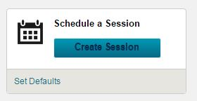Click on the **Schedule a Session** button:
5. You will be presented with an options screen. Here you will input the session name, the start and end times, and many other options. Feel free to set these options as you choose.
6. Once you are happy with your session settings, click the **Save** button.
7. You will be brought back to the Blackboard Collaborate tool. Here you will see your sessions listed under the scheduled sessions area:  
   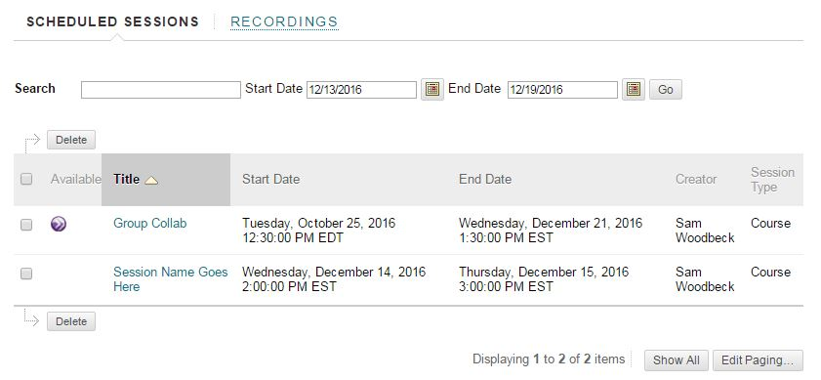
8. C:\Users\swoodbec\Desktop\Learning Tech Spec Resources_Current Projects\Faculty Survival Guide\Images\Doc Images\DropDown.JPG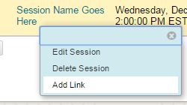Hovering over the session name will give you a contextual menu:
9. This contextual menu will give you the option to **Add Link**, which allows you to embed a link to the session for your students in a content area within your course.
10. 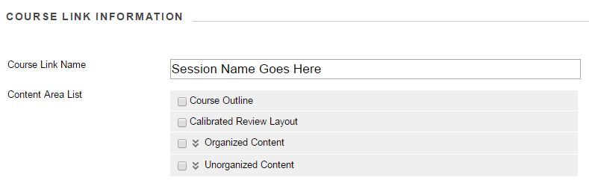Clicking this will allow you to name the session within the content area, and select where you’d like it to appear in your course:
11. Once you are happy with these options, click **Save.** This will deploy the session link to the desired content area.
12. Visiting this content area will now show you a linkage to the session:  
    
13. Your students will now be able to click on the session and join you in Blackboard Collaborate.