

**Accessing Employee Information**

Follow these steps to access your employee information online via the Confederation College Portal.

1. Navigate to <http://www.confederationcollege.ca> and login to MyCampus Portal. More detailed instructions on logging in are outlined in the **Logging into the Confederation College Portal** documents in the Faculty Survival Guide.
2. 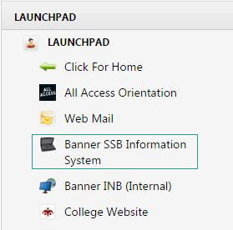Within your Portal Launchpad, access the **Banner SSB Information System**.
3. 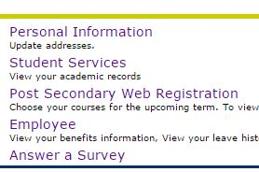Within Banner, you will find the following options:
4. You will find your employee information in the **Employee** section.