Welcome to our New Portal
Tips / Techniques
How to create your own favourites dropdown:
From the landing page click on your profile name in the top right corner
Select preferences
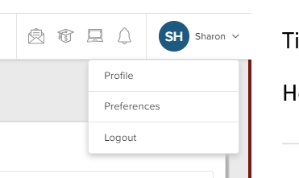
Click on MANAGE beside Manage Favourites
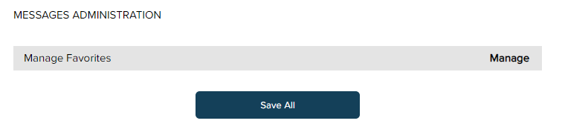
Click on the items that you want to have in your favourites list

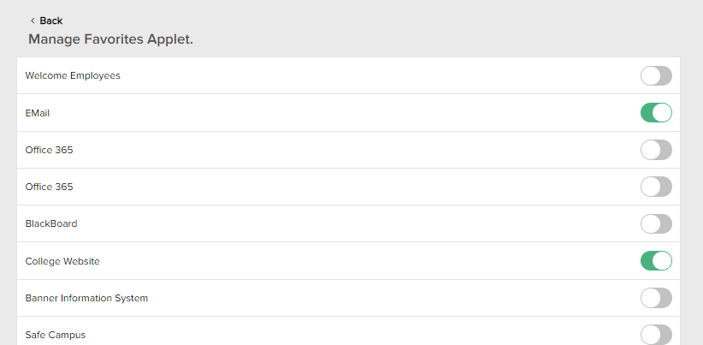
Click Save All at the bottom of the page
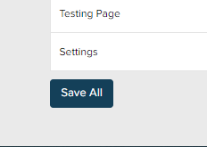
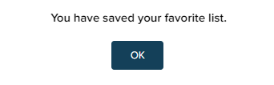
You now have a favourites drop down on your main menu
