SERVATHON PHOTO CONTEST
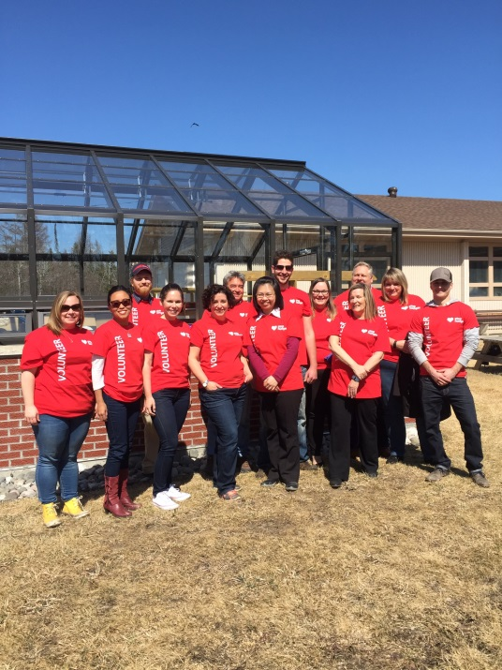
PLEASE VOTE FOR US!!
‘Like’ our Photo on Sodexo Canada’s Facebook Page and we could win up to $1,000 from Sodexo’s Stop Hunger Foundation to donate to a local Charity!
1st Place: $1,000 Grant
2nd Place: $500 Grant
3rd Place: $250 Grant
https://www.facebook.com/pg/sodexo.ca/photos/?tab=album&album_id=1683946098299517
Contest closes Sunday May 28th

