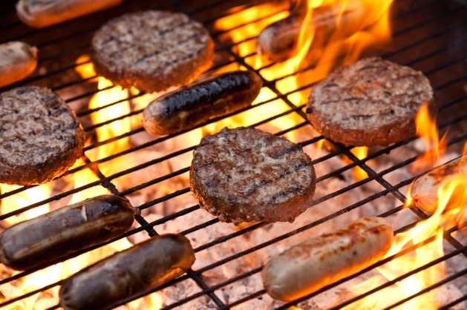
EVERY WEDNESDAY > 11:30AM-1:00PM
(In the Courtyard by the Shuniah Building)

BEEF BURGER 5.50

BISON BURGER 6.50

JUMBO DOG 4.00

TURKEY SAUSAGE 4.50

Add Cheese .75
Canned Juice or Pop 1.50
Combo Any Item 3.00 (Canned Beverage & Chips)
(Prices include HST)

